**Termwork 9**

Name : VISHWAS GURUVADEYAR

USN : 2GI20CS042

Date: 30/05/2023

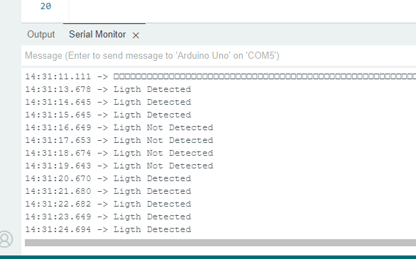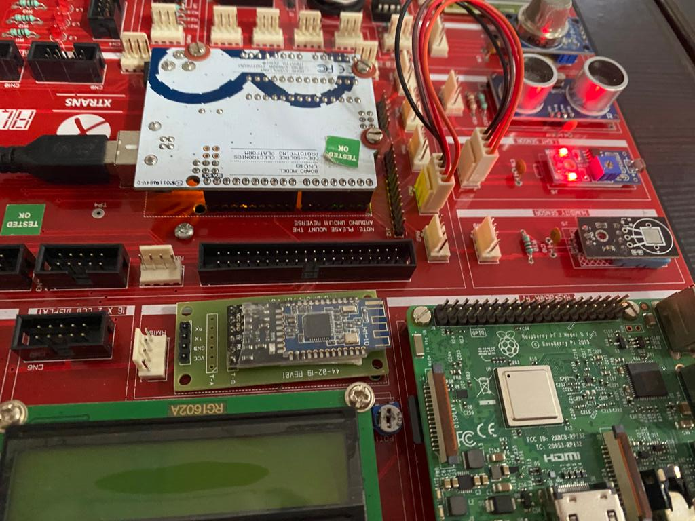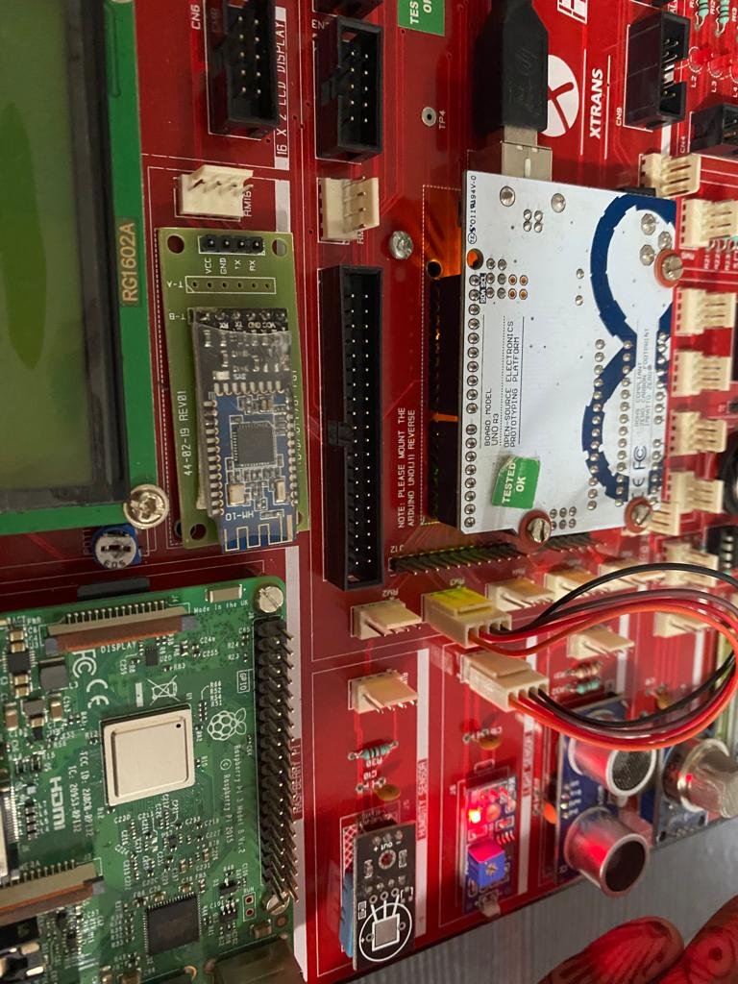

Light detected : Light not detected :